**How many satellites will be launched next year**

Can we forecast a number of satellites that will be active in 2020?

The space age began on October 4, 1957, with the launch of the first artificial satellite, Sputnik 1. This tiny spacecraft lasted only three months in orbit, finally burning up in the Earth’s atmosphere. Since this situation has changed, current there are more than 1400 active satellites in orbit.

This project outlines the active satellites current situation and draws up some future projections such as the number of satellites that will be launched in 2017.

This project aims to classify and identify the observations. Here, for example, data analysis may identify:

* How many satellites will be launched next year
* How many satellites does a given country have in orbit, and what are they used for?
* How many satellites are used for military purposes versus commercial purposes?
* Which countries have earth-observing satellites?
* When was the oldest working satellite launched?
* At what altitudes do most satellites orbit?
* What activities are most satellites involved with?

The findings may be of interest to scientists, to supply of electronic components, etc.

The database contains 26 types of data for each satellite, including technical information about each satellite (mass, power, launch date, expected lifetime) and its orbit (apogee, perigee, inclination, and period), as well as information on what the satellite is used for, and who owns, operates, and built the satellite.

If the data scientist wants that the many hours invested in the analysis to be fruitful, its conclusions must be understood and accepted.

This project will also allow reporting results and findings in a convincing and impactful way by using advanced tools such as topographical graphs. For example set up an interactive map with different colours according to the density.

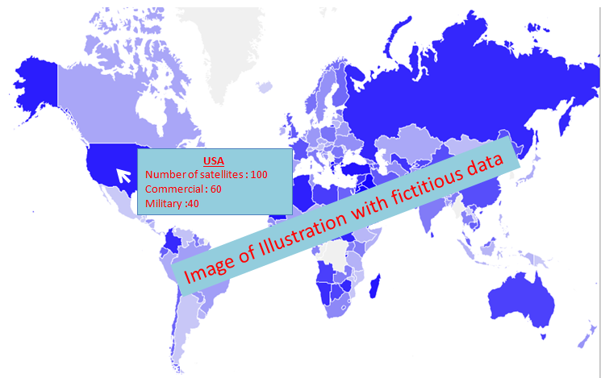

**Figure 1: Example of presentation**

This project will focus on:

* Classification data analytics tools;
* interpret results with a business mindset;
* how to report and communicate findings efficiently regardless of the analytics tools used

Dataset is from is from kaggle : https://www.kaggle.com/ucsusa/active-satellites